**Figure S1**. Vervet chromosome size distribution.

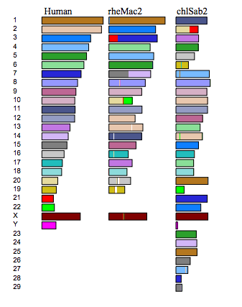

**Figure S2**. Whole genome alignments of human (hg19), vervet (Chlorocebus_sabeus 1.1) and rhesus macaque (rheMac2).



**Figure S3.** The fission that generated vervet chromosomes 24 and 29 is mapped to a single rhesus macaque BAC CH250-181A5.



**Figure S4.** Human 14 region of breakpoint origin for CAE24 and CAE29.



**Figure S5.** A summary of segmental duplication content in vervet chromsomes that have experienced fissions compared to those that have not.



**Figure S6**. Gene copy number for LENG1 in the primate lineage among sequenced primates (source is Ensembl gene trees database).

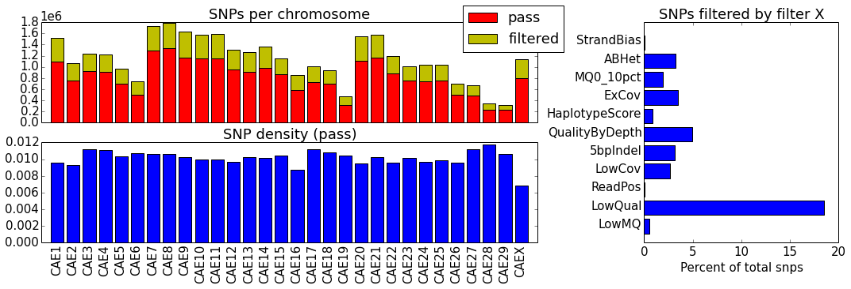

**Figure S7**. Total subspecies filtered single nucleotide polymorphisms per vervet chromosome



**Figure S8.** Tile path of individual assembled BACs interspersed with whole genome assembly contigs for the vervet MHC region. Blue blocks represent individual clones and green blocks are interspersed whole genome assembled contigs. The assembled BAC tile path is available upon request.

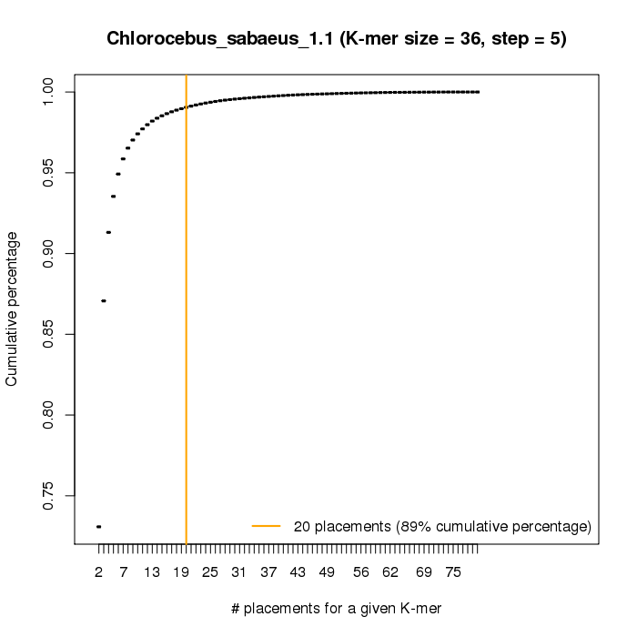

**Figure S9.** Cumulative distribution of additional masking achieved by masking over-represented kmers.