Supplemental Figure Legends: Supplemental Fig. 1
Heatmap of gene expression in three publicly available microarray datasets. Left: NCBI GEO accession GSE54088 (Evans et al., 2014); spermatogenesis synchronized with WIN18,446/RA treatment. Middle: GSE12769; unsynchronized. Right: GSE926 (Shima et al., 2004), unsynchronized. d.p.p., days postpartum. A,B sp.gonia, type A,B spermatogonia.
Plotted values are log2(fold-change) compared to undifferentiated spermatogonial time-point (0 d after RA for GSE50488; average of 0 d.p.p. and 3 d.p.p. for GSE12769 and GSE926). All genes that are significantly changed in any dataset are plotted (2571 genes total).
Dendrogram (left of heatmap) shows hierarchical clustering of expression patterns; dendrogram was cut to give 20 distinct clusters, which were then individually scored for concordance between synchronized and unsynchronized datasets (black bars, right of heatmap). For 17/20 clusters (comprising 95% of the examined genes), we find that gene expression patterns in the synchronized dataset are more concordant with at least one of the unsynchronized datasets than the unsynchronized datasets are with each other. We note that the few instances of discordance between the synchronized and unsynchronized datasets may be due to technical artifacts (for example from the use of different microarray platforms).
Developmentally most advanced germ cell type at each time-point (top) taken from Fig. 4A, (Kluin et al., 1982; Shima et al., 2004). Note that in the unsynchronized datasets the most advanced germ cell type is not generally the most prevalent germ cell type: for example while spermatocytes have appeared by 10 d.p.p. they are not the most prevalent germ cell type until 14 d.p.p. (Nebel et al., 1961).

Supplemental Figures: Supplemental Fig. 1
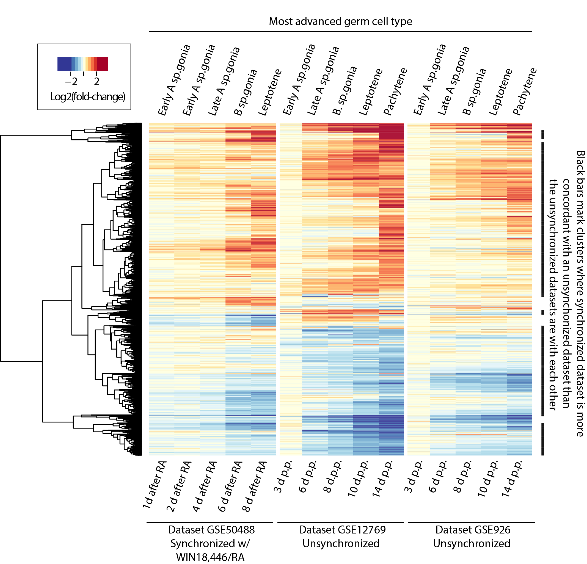

Supplemental References
Evans E, Hogarth C, Mitchell D, Griswold M. 2014. Riding the spermatogenic wave: profiling gene expression within neonatal germ and sertoli cells during a synchronized initial wave of spermatogenesis in mice. Biol Reprod. 90:108. doi:10.1095/biolreprod.114.118034.
Kluin PM, Kramer MF, de Rooij DG. 1982. Spermatogenesis in the immature mouse proceeds faster than in the adult. Int J Androl. 5:282-94. doi:10.1111/j.1365-2605.1982.tb00257.x.
Nebel BR, Hackett EM, Amarose AP. 1961. Calendar of gametogenic development in prepuberal male mouse. Science. 134:832-3. doi:10.1126/science.134.3482.832.
Shima JE, McLean DJ, McCarrey JR, Griswold MD. 2004. The murine testicular transcriptome: characterizing gene expression in the testis during the progression of spermatogenesis. Biol Reprod. 71:319-30. doi:10.1095/biolreprod.103.026880.

