Supplementary Figure 1. Alignment of long-read sequence to laboratory host E. coli bacterial genomic DNA. Some E. coli genomic DNA copurified with the BAC prior to microinjection is co-inserted at each integration site within each transgenic line. Aligned regions ranged from ~2.4- to ~68-kbp.
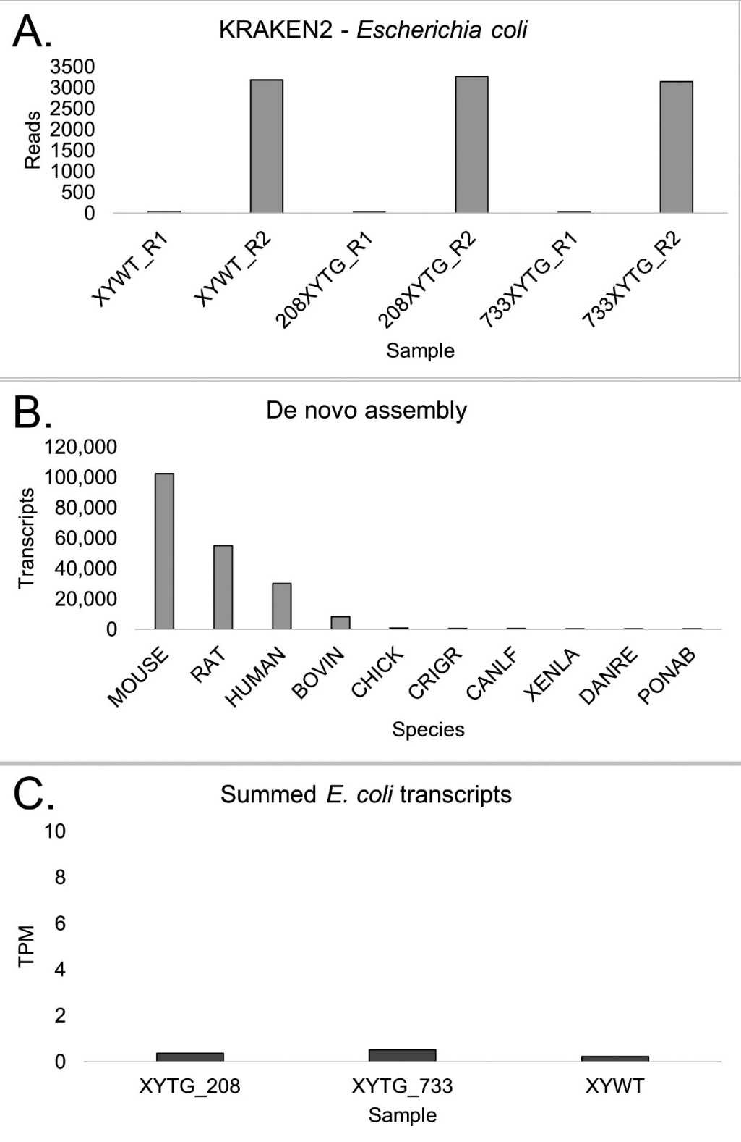
Supplementary Figure 2: Testing for expression of E. coli transcripts
A. The number of reads mapping to E coli genome from either end (R1 or R2) of liver RNAseq per sample. The read numbers were similar in two transgenic lines 208 and 733, which contain some E. coli genome, relative to an XYWT male, which lacks any E. coli genome, indicating that read numbers were at background in each case. B. Number of transcripts per species from de novo assembly. BOVIN, bovine; CRIGR, Cricetulus griseus (Chinese hamster); CANLF, Canis lupus familiaris (dog); XENLA, Xenopus laevis; DANRE, Danio rerio; PONAB, Pongo abelii (Sumatran orangutan). C. Transcripts per million (TPM) of the three de novo constructed E. coli transcripts were all below 1 TPM background noise.

